# Alphabets by for loop in C++

1)A

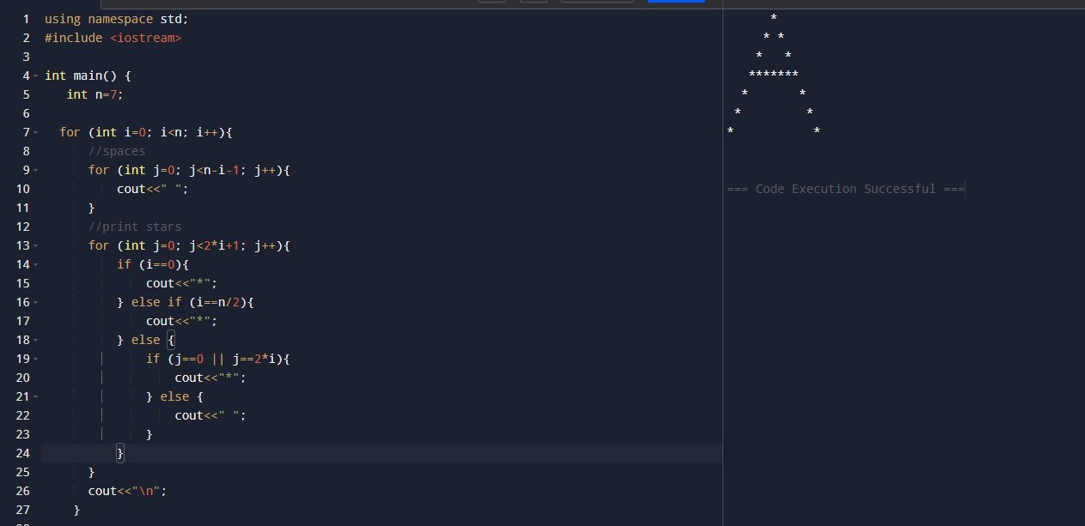

3)C

4)D

5)E

6)F

7)G

8)H

9)I

10)J

